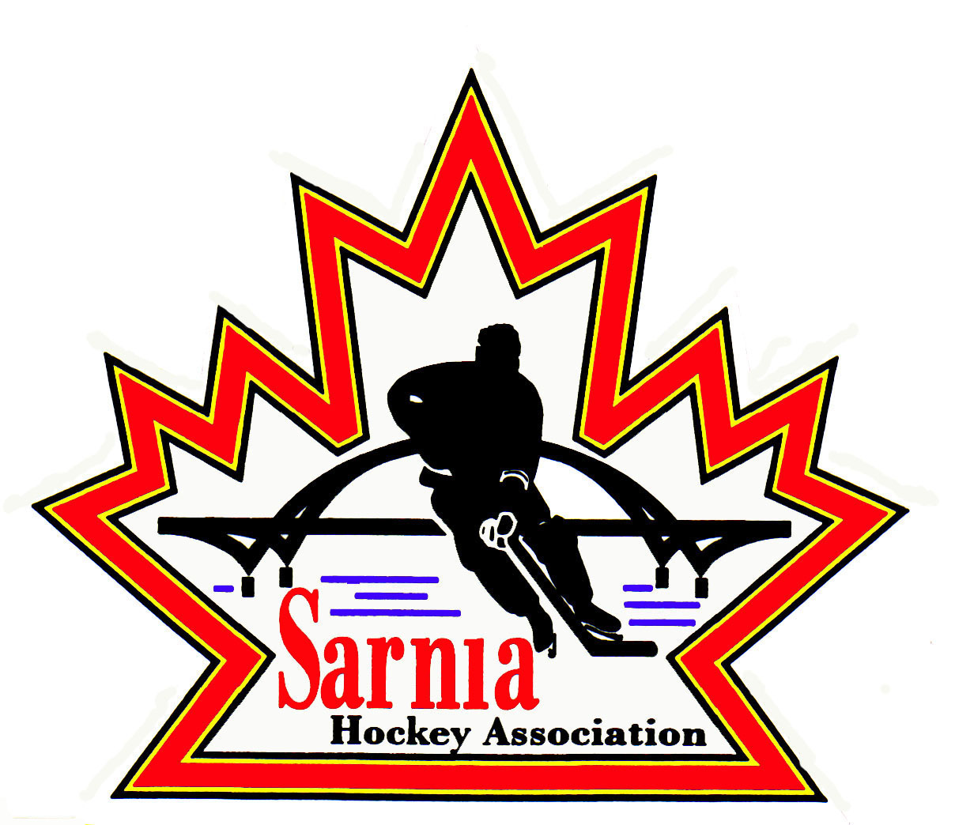

Sarnia Hockey Association

Minutes | Date: December 3, 2024 | time 7:00 pm

Meeting called by | Paul Walsh, President
Type of meeting | Regular
Secretary | Kelly Lane, Recording Secretary

Welcome | Paul Walsh, President, and meeting Chair welcomed everyone and called the meeting to order at 7:03 pm.

ATTENDANCE | Heather Amaral, Andrew Beasley, Jerry Bernardo, Alister Brown, Emily Brown, Darren Chevalier, Brendan Douglass, Ian Dunn, Chuck Ewart, Jeff Fogal, Pat Forbes, Dan Hunt, Kelly Lane, Cris LaPointe, Don McGugan, John Mellor, Jeffrey Needham, David Penner, John Ritchie, Wayne Scarrow, Jason Teather, Tim Turner, Barb Walsh, Paul Walsh  Regrets: Jacquie Beasley, Terry Gray, Linda Lauzon, Bonny Marcy, Don McGugan, Kyle Mellor, Ted Pendle, Lesley Smith-Taylor, Kevin Taylor

ACCEPTANCE OF MINUTES | MOTION #241203-001  “That the Minutes from November 20, 2024, be accepted as presented.” (Forbes/Hunt)  Carried

TREASURER’S REPORT | - Financial Report was sent out prior to the meeting for review.  - Bank interest line – $2337.02 is due to cashed in GIC’s.  - Player registration this month was $75,5005.06 which is primarily rep assessment fees.  - Select tryout – some of the payments that came in for tryout fees came in through HCR. We can’t cleanly separate HCR payments due to large transfer.  - Ice costs for rep and rec – it’s a taxing process. Given total ice is one big bundle. Allocated smaller bill to rec due to smaller amount of ice used. We will be able to reconcile more once the Ice Scheduler is caught up.  - Referee line – one of the rep teams had a series of exhibition games and they were billed and paid that bill.  - It was noted that we separate rec and rep ice as that is how we determine assessment fees, and it is based on ice usage. It is a user pay system.  MOTION #241203-002  “That the Treasurer’s report be accepted as presented.” (E. Brown/Ritchie)  Carried

BILLS TO BE PAID | MOTION #241203-003  “That the bills be paid as presented.” (E. Brown/Ewart)  Carried
  Recipient | Expense | Amount
  Planet Stitch  Dark Horse Goaltending  Kyle Mellor  Jerry Bernardo  Bluewater Referees  Darren Rogers  City of Sarnia | Benevity grant covering name bars  U13 BB Practice – Cousi funded  Silver Stick game pucks  SHA Hockey Day Sponsor hospitality  November referee costs  PEP Sessions for U7 and U15 teams  Referee Clinic  Board Meeting room  Rec/Rep/Select Ice  Misc room rentals | $ 146.90  $ 150.00  $1,745.85  $ 422.40  $10,446.00  $1,084.80  $176.47  $151.23  $122,517.09  $222.47

SILVER STICK | - This weekend is U11 and U18 AAA Silver Stick.  - 28 teams at Clearwater, PASA and Pat Stapleton Arenas.  - Starts Thursday night and ends on Sunday.

WINTER CLASSIC TOURNAMENT | - Winter Classic draft schedule has been sent out.  - Some gaps so that we don’t get overages.  - Volunteers needed. Reach out to Jeff Fogal.  - Need Directors to hand out awards on Sunday.

NEW BUSINESS | NEXT MEETING:  - Next meeting is Tuesday, January 7, 2025 at 7:00 pm at Clearwater Arena Lower Hall.

adjournment | MOTION #241203-004  “That the meeting be adjourned.” (E. Brown/Hunt)  Carried

Paul Walsh Kelly Lane
President Secretary

